ETEC 326 Milestone 1 Detailed Design – Quadcopter

Group Members:

Randy Ropan

Dmytro Turynok

Van Phuoc Duy Nguyen

Mohammed Abraar

Scope (Dmytro): The self-assembled quadcopter that is made of components off the shelf to simplify the production. The following off shelf components are flight controller, speed controller, antenna, battery, and frame. However, drone will be controlled by the mobile application that allow users to be more flexible, plus avoid usage of massive remote controllers that could be found on a market. At the same time, a novelty to the project is a payload system with soft robotic gripper, which will be self-designed and printed on a 3D printer. The robotic gripper will be controlled by the same mobile application which will be used for the remote control of the drone. The load that we are planning to carry on with the drone must be approximately 1.5 kg.

Resources (Dmytro):

1. Quadcopter Hardware Overview – Every Component Explained (Link: <https://oscarliang.com/quadcopter-hardware-overview/> )
2. User manual of Flight Controller + ESC (stack): <https://speedybee.s3.amazonaws.com/Manual/MANUAL-F7MINI-STACK-EN.pdf>
3. Control a drone with a phone: <https://robocraze.com/blogs/post/how-to-control-drone-using-android>
4. Soft robotic gripper, user guide: <https://www.instructables.com/Print-in-Place-Robotic-Gripper/>
5. Rotor Village, order parts online: <https://rotorvillage.ca/>

Schedule (Randy):

I created a schedule that laid out the project plan for the Quadcopter using a template I found online. I listed each task name and assigned those specific tasks to the corresponding person in the group. For example, the hardware diagram is assigned to Dmytro, the design/schematics of the drone is assigned to me, the bill of materials is assigned to Van, and the design/schematics of the claw system is assigned to Mohammed. Each task has a start date, end date, duration, priority, and status section displayed below.

|  |  |  |  |  |  |
| --- | --- | --- | --- | --- | --- |
| PROJECT NAME | Quadcopter with Payload System | | | INSTRUCTOR | Mark Thomas |
| PROJECT DELIVERABLE | Functional 5-inch drone w/ modified claw system mounted underneath frame controlled via app from smartphone | | | | |
| SCOPE STATEMENT | Drone will pick up a load to transport and carry by claw system | | | | |
| START DATE | 01/24/2024 | END DATE | 02/18/2024 | OVERALL PROGRESS | 50% |
|  |  |  |  |  |  |

|  |  |  |  |  |  |  |
| --- | --- | --- | --- | --- | --- | --- |
| **TASK NAME** | **ASSIGNED TO** | **START**  **DATE** | **END**  **DATE** | **DURATION**  in days | **PRIORITY** | **STATUS** |
| Initialization | Everyone | 01/17 | 01/24 | 7 | Not Urgent | Completed |
| Review Capstone Project | Everyone | 01/17 | 01/24 | 7 | Not Urgent | Completed |
| Research Components | Everyone | 01/24 | 02/03 | 10 | Critically Urgent | Completed |
| Hardware Diagram | Dmytro | 01/31 | 02/13 | 13 | Important | In Progress |
| Software Diagram | Dmytro | 01/31 | 02/13 | 13 | Important | In Progress |
| Schematic/Design of Drone | Randy | 01/31 | 02/13 | 13 | Critically Important | In Progress |
| Schedule/WBS Structure | Randy | 01/31 | 02/13 | 13 | Important | In Progress |
| Technical Specifications | Van | 01/31 | 02/13 | 13 | Critically Important | In Progress |
| Bill of Materials | Van | 01/31 | 02/13 | 13 | Important | In Progress |
| Schematic of Claw System | Abraar | 01/31 | 02/13 | 13 | Important | In Progress |
| Budget | Dmytro, Randy | 02/01 | 02/13 | 12 | Important | Completed |
| Purchasing Components | Dmytro | 02/05 | 02/07 | 2 | Important | Completed |
| Hardware Assembly | Everyone | 02/19 | 02/23 | 5 | Important | Not Yet |
| 3D Print Claw System | Dmytro, Abraar | TBA | TBA | TBA | Important | Not Yet |
| Programming | Dmytro | TBA | TBA | TBA | Not Urgent | Not Yet |
| Project Test/Functionality | Everyone | TBA | TBA | TBA | Not Urgent | Not Yet |
| Records of Documentation | Everyone | TBA | TBA | TBA | Not Urgent | Not Yet |
| Finalization of Project | Everyone | TBA | TBA | TBA | Not Urgent | Not Yet |

Work Breakdown Structure (WBS) (Randy):

**Quadcopter Project WBS February 1st-13th**

|  |  |  |
| --- | --- | --- |
| **Phase** | **WBS** | **Task Description** |
| 1. | **1.1 Initialization** | 1.1.1 Review Capstone Project |
| 1.1.2 Scope Statement |
| 1.1.3 Research Components |
| 1.1.4 Project Approval |
| 2. | **1.2 Planning** | 1.2.1 Schedule |
| 1.2.2 Hardware Diagram |
| 1.2.3 Software Diagram |
| 1.2.4 Drone Schematic & Design |
| 1.2.5 Claw System Schematic & Design |
| 1.2.6 Budget |
| 1.2.7 Technical Specifications |
| 1.2.8 Bill of Materials |
| 1.2.9 Purchasing Components |
| 3. | **1.3 Executing** | 1.3.1 3D Print Claw System |
| 1.3.2 Hardware Assembly |
| 1.3.3 Soldering |
| 1.3.4 Programming |
| 1.3.5 Inspection |
| 4. | **1.4 Control** | 1.4.1 Time Management |
| 1.4.2 Cost Management |
| 1.4.3 Risk Management |
| 1.4.4 Quality Management |
| 5. | **1.5 Closeout** | 1.5.1 Cleanup |
| 1.5.2 Functionality Test |
| 1.5.3 Records of Documentation |
| 1.5.4 Submission |

Responsibility Assignment Matrix (RAM) (Randy):

Legend:

**R** = **Responsible:** Person who is completing the task

**A** = **Accountable:** Person who is making decisions and taking actions on the task(s)

**C** = **Consulted:** Person who will be communicated with regarding the decision-making process and specific tasks

**I** = **Informed:** Person who will be updated on decisions and actions during the project

|  |  |  |  |  |  |
| --- | --- | --- | --- | --- | --- |
| Deliverable | Task | Randy | Dmytro | Van | Mohammed |
| **1.1 Initialization** | Review Capstone Project | **R** | **R** | **R** | **R** |
| Scope Statement | **C** | **R** | **I** | **I** |
| Research Components | **R** | **A** | **R** | **C** |
| Project Approval | **I** | **A** | **I** | **I** |
| **1.2 Planning** | Scheduling | **R** | **A** | **C** | **C** |
| Hardware Diagram | **A** | **R** | **C** | **A** |
| Software Diagram | **C** | **R** | **A** | **C** |
| Drone Schematic & Design | **R** | **A** | **I** | **C** |
| Claw System Schematic & Design | **I** | **A** | **C** | **R** |
| Budget | **I** | **R** | **I** | **I** |
| Technical Specifications | **A** | **C** | **R** | **A** |
| Bill of Materials | **C** | **I** | **R** | **I** |
| Purchasing Components | **C** | **R** | **C** | **C** |
| **1.3 Executing** | 3D Print Claw System | **C** | **A** | **C** | **R** |
| Hardware Assembly | **R** | **R** | **R** | **R** |
| Soldering | **R** | **R** | **A** | **A** |
| Programming | **A** | **R** | **I** | **C** |
| Inspection | **A** | **I** | **R** | **R** |
| **1.4 Control** | Time Management | **R** | **I** | **I** | **I** |
| Cost Management | **I** | **R** | **I** | **I** |
| Risk Management | **I** | **I** | **R** | **I** |
| Quality Management | **I** | **I** | **I** | **R** |
| **1.5 Closeout** | Cleanup | **R** | **R** | **R** | **R** |
| Functionality Test | **A** | **R** | **R** | **A** |
| Records of Documentation | **R** | **R** | **R** | **R** |
| Submission | **C** | **R** | **C** | **C** |

Bill of Materials (Van):

|  |  |  |  |  |  |
| --- | --- | --- | --- | --- | --- |
| Component | Part name | Spectifications | Quantity | Price | Manufacturer |
| Frame | TBS SOURCE ONE V5 - 5" | Wheelbase 5": 226 Top Plate: 2mm Middle Plate: 2mm Bottom Plate: 2.5mm Arms Spacer: 6mm Camera plate: 2mm Standoff height: 30 and 22mm Arm thickness 5": 6mm Stack Mounting: 30.5 × 30.5mm & 20 x 20 Weight 5": *123.5g | 1 | $46.99 | Team BlackSheep |
| Propeller | GEMFAN F3S FREESTYLE TRI-BLADE PROP | Material: PC Weight: 3.5g Pitch: 3in Prop Dia: 5.1in (129mm) Center Thickness: 6mm Center Hole Dia: 5mm  Suggested Quad Weight: 550-650g Recommended Motor 4S 2300-2500kv 6S 1650-1950KV | 4 | $11.88 | Gemfan |
| Receiver | HAPPYMODEL EXPRESSLRS EP1 2.4GHZ RX | Type: ISM ESP8285 MCU SX1280IMLTRT RF Module Omnidirectional antenna Frequency Range: 2400 MHz to 2500 MHz Maximum receive refresh rate: 500Hz Minimum receiver refresh rate: 25Hz Working voltage: 5v Weight: 0.42gram(without antenna) Dimension: 10mm*10mm*3mm Peak gain: 2.23dB Package include 1pcs 40mm and 1pcs 90mm Omnidirectional antenna | 1 | $19.99 | Happymodel |
| Motor | T-MOTOR VELOX V3 2207 1950KV MOTOR | Configuration: 12N14P Lead Cable: 20#, 150mm Weight: 37.41g Rated Voltage (Lipo): 6s Idle Current (10V): 132A Max Power (60s): 1050.5W Peak Current (60s): 45.0A Out Diameter: 5mm In Diameter: 4mm | 4 | $83.96 | T-Motor |
| Battery | GNB 2300MAH 6S 50C LIPO - XT60 | Model No.: GNB23006S50A Capacity: 2300mAh Voltage: 22.2V Cells Configuration: 6S1P Pack Dimension: 48*34*110mm (H*W*L) Net Weight: 341g (+/-6g) Discharge Rate: 100C Charge Rate: 1C to 5C Discharge Connector: XT60 | 1 | $46.99 | GNB |
| Flight Controller | SPEEDYBEE F405 V3 30X30 FLIGHT CONTROLLER | MCU: STM32F405 IMU(Gyro): BMI270 USB Port: Type-C Barometer: Built-In OSD Chip: AT7456E chip BLE Bluetooth: Supported DJI Air Unit Connection: 6-pin connector and solder pads Blackbox Micro-SD Card: 32GB max Current Sensor: Supported Power Input: 3S-6S LiPo Motor Signal Inputs: up to 8 for X8, Y6 and more configurations Power Output: 9V (2A), 3.3V (500mA), 4.5V(1A), 5V(2A) ESC Signal: M1-M8 available UART: 5 Sets I2C: Supported LED: Supported Buzzer: Supported Boot Button: Press for DFU mode, press when powered to change LED modes Firmware Target: SPEEDYBEEF405V3 Mounting: 30.5 x 30.5mm (4mm hole diameter) Dimensions: 41.6(L) x 39.4(W) x 7.8(H)mm Weight: 9.6g | 1 | $49.99 | SpeedyBee |
| Speed Controller | SPEEDYBEE BLS 50A 30X30 4IN1 ESC | Firmware: BLHeli_S JH50 Wireless Configuration: Full Configuration Supported in Speed Bee App PC Configurator: https://esc-configurator.com/ Continuous Current: 50A * 4 Burst Current: 55A * 4 TVS Protective Diode: YES External Capacitor: 1500uF Low ESR Capacitor Included ESC Protocol: DShot 300/600 Power Input: 3-6S LiPo Power Output: VBAT Current Sensor: Scale=386 Offset=0 Mounting: 30.5 x 30.5mm ( 4mm hole diameter ) Dimensions: 45.6(L) * 44(W) * 6.1mm(H) Weight: 13.8g | 1 | $49.99 | SpeedyBee |

Hardware Diagram (Dmytro):

GPS

Optical flow sesor

Camera module

Telemetry

3D printed claws

Servo Motor

Bluetooth (Rx)

Payload system

Propellers

Motor

Electronic Speed Controller (ESC)

Driving unit

AV Receiver

RC Transceiver

Ground Control System (GCS)

Comm.unit

Flight Controller Board

Main Processor

Off-board module

Bluetooth (Tx)

Temperature sensor

Barometer

Magnetometer

* Gyroscope
* Accelerometer

Signal input/Protocol

RF

PWM

UART

I2C

Software Diagram (Dmytro):

Flight Control Software

“1”

“0”

If Input payload button = 1

Flight Algorithm (PID)

Payload Actuation signals

“0”

“10”

“01”

Drive motors

Release/ Grip

Motor sleep mode

3-axis claw release

“1”

3-axis claw grip

“01”

Activate motor

“00”

Up/Down

Turning left/right

“00”

“10”

“01”

“11”

Go down

Go up

Go left

Go right

**Flight Control Software**: This software module includes algorithms for stabilizing the drone during flight, such as PID (Proportional-Integral-Derivative) controllers.

**Payload Control Software**: This software module manages the control of the payload attached to the drone, such as a gripper. It may include logic for opening, closing, and manipulating the payload.

**Flight Algorithms**: These algorithms process sensor data (e.g., IMU, GPS) to determine the appropriate motor control signals needed to stabilize and maneuver the drone.

**Payload Control Algorithms**: These algorithms interpret commands received from the payload control software and generate control signals to actuate the payload mechanism accordingly.

**Motor Control Signals**: These signals, typically in the form of PWM (Pulse Width Modulation), are sent from the flight control software to the ESCs (Electronic Speed Controllers) to adjust the speed of the motors.

**Payload Actuation Signals**: These signals are generated by the payload control software and sent to actuators or control hardware to manipulate the payload mechanism.

**Motor Outputs**: These signals are received by the motor controllers (motor drivers), which then drive the motors accordingly.

**Payload Outputs**: These control signals are received by the payload controller (microcontroller), which then actuates the payload mechanism.

**Drone Hardware**: This encompasses all physical components of the drone, including motors, ESCs, and the flight controller.

**Payload Hardware**: This includes the mechanical and electrical components of the payload, such as actuators and sensors.

**Bluetooth Communication**: While not explicitly depicted in the diagram, Bluetooth communication between the drone and the remote controller enables commands from the controller to be sent to the flight control and payload control software modules. This communication allows the user to control the drone's flight and payload operation remotely via a smartphone or other Bluetooth-enabled device.

Schematics (Design of Drone) (Randy):

**Hand-drawn:**

I started the design/schematics of the drone. I looked at designs online to get an idea of what kind of design we wanted to do. We settled for a traditional ‘X’ frame design. The frame model shown below is called the “**TBS SOURCE ONE V5”** and it’s 5 inches in length. I did a hand drawn schematic of the drone design based off this model from the top view. The flight controller, ESC, receiver, battery, and antenna are located inside the frame. We plan on 3D printing the propellors.

**NOTE: We decided to purchase the propellors from off the shelf.**

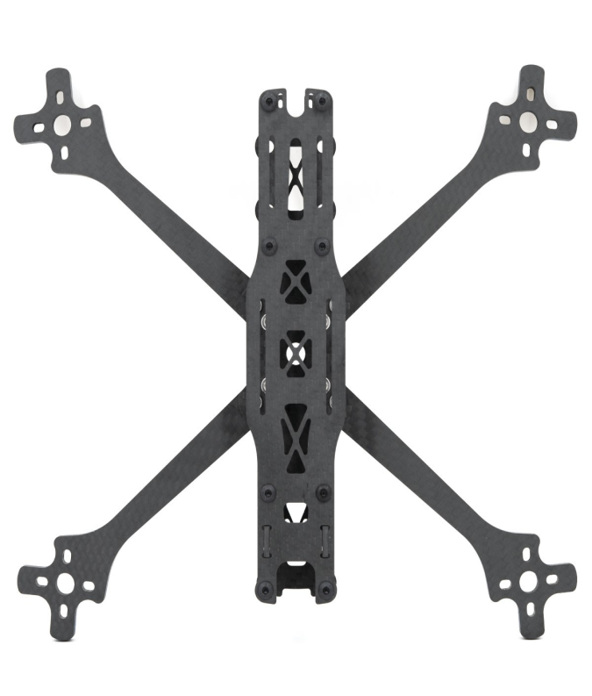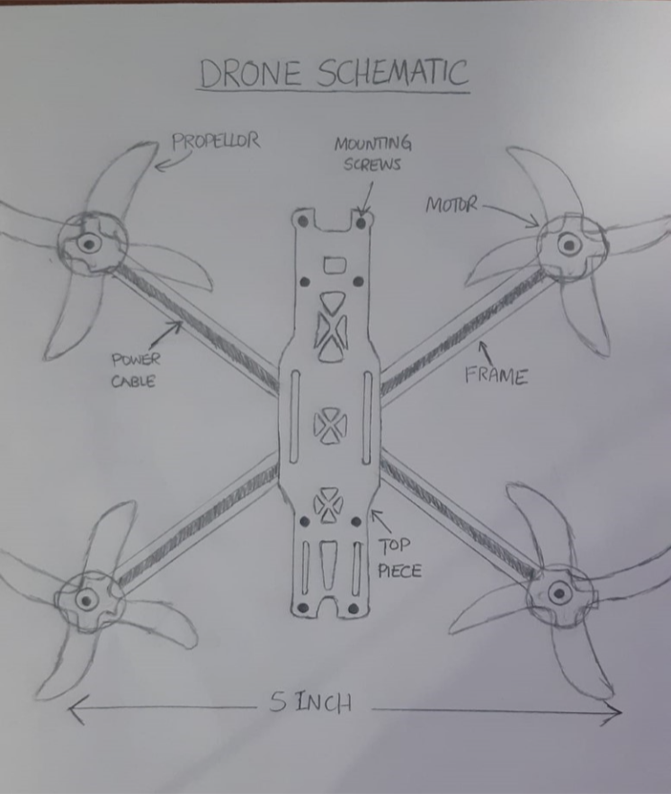

**Digital:**

I created a new schematic digitally using Microsoft 3D Paint. I labelled each component in the diagram to give us a better idea of the project’s assembly.

**NOTE: We are not using an FPV Camera in our build due to budget constraints.**

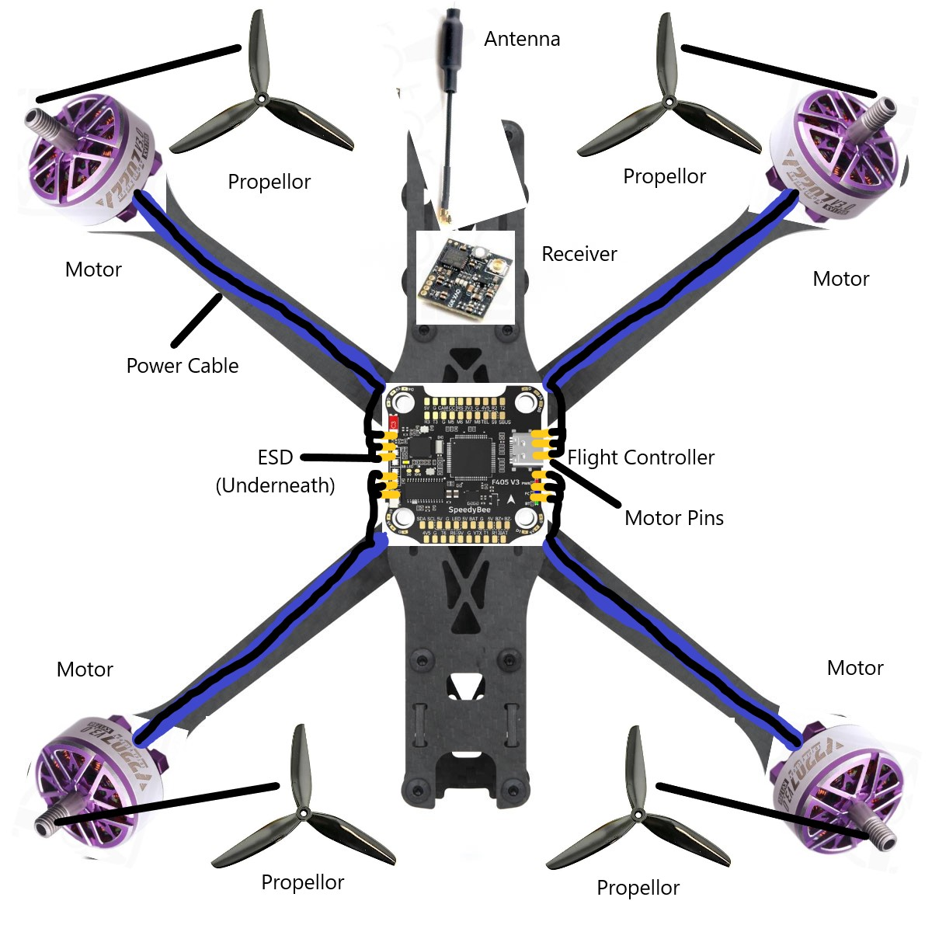

Schematics (Design of Claw System) (Abraar):

Designed and tried the claw system, first attempt to 3d print the claw system was made but because of the material was unfoldable , working on the new design and customizing the material.

Comments/Any changes made (Anyone):

Scrapped FPV camera